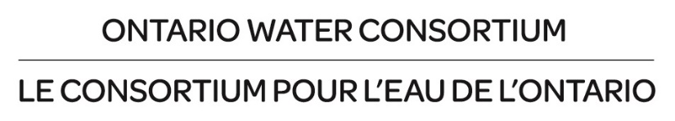

Municipal Water Challenges
Intake Form

Please complete the Municipal Water Challenges Intake Form and submit it to OWC as directed below.

The purpose of this form is to collect and build a catalogue of Municipal Water Challenges. This comprehensive map of the pressures and obstacles faced in municipal water management can then be cross-referenced with OWC’s platform and wider network to find the solutions that end-users are seeking.

Only after obtaining permission from the municipality will information obtained from this document be used to determine potential partnerships with solutions providers, such as water technology companies or post-secondary partners to assist in identifying a relevant academic researcher, if needed.

1.0 Contact Information

Name:
Title:
Affiliation:
E-Mail:

2.0 Challenge Area

What are your municipality’s challenge areas of focus (select any that apply)?

☐ Analytics, Monitoring ☐ Net Zero Energy Wastewater Treatment
☐ Drinking Water Treatment ☐ Resource Recovery
☐ Energy Optimization ☐ Sensors
☐ Industrial Water Treatment ☐ Stormwater Management
☐ Wastewater Treatment ☐ Water Reuse
☐ Human Resources ☐ Lean Management

Other:

3.0 Challenge Information

Briefly describe the water management challenges that your municipality is currently facing:

Briefly describe the water management challenges that your municipality may face in the future:

What is your municipality currently doing to address these challenges?

What type of support is your municipality seeking from OWC to address these challenges?

Additional comments:

Please submit the completed form to robert@ontariowater.ca.

